## Step 1: we will take the main. C file from previous led project

## Step 2: we will write startup.s file as shown below

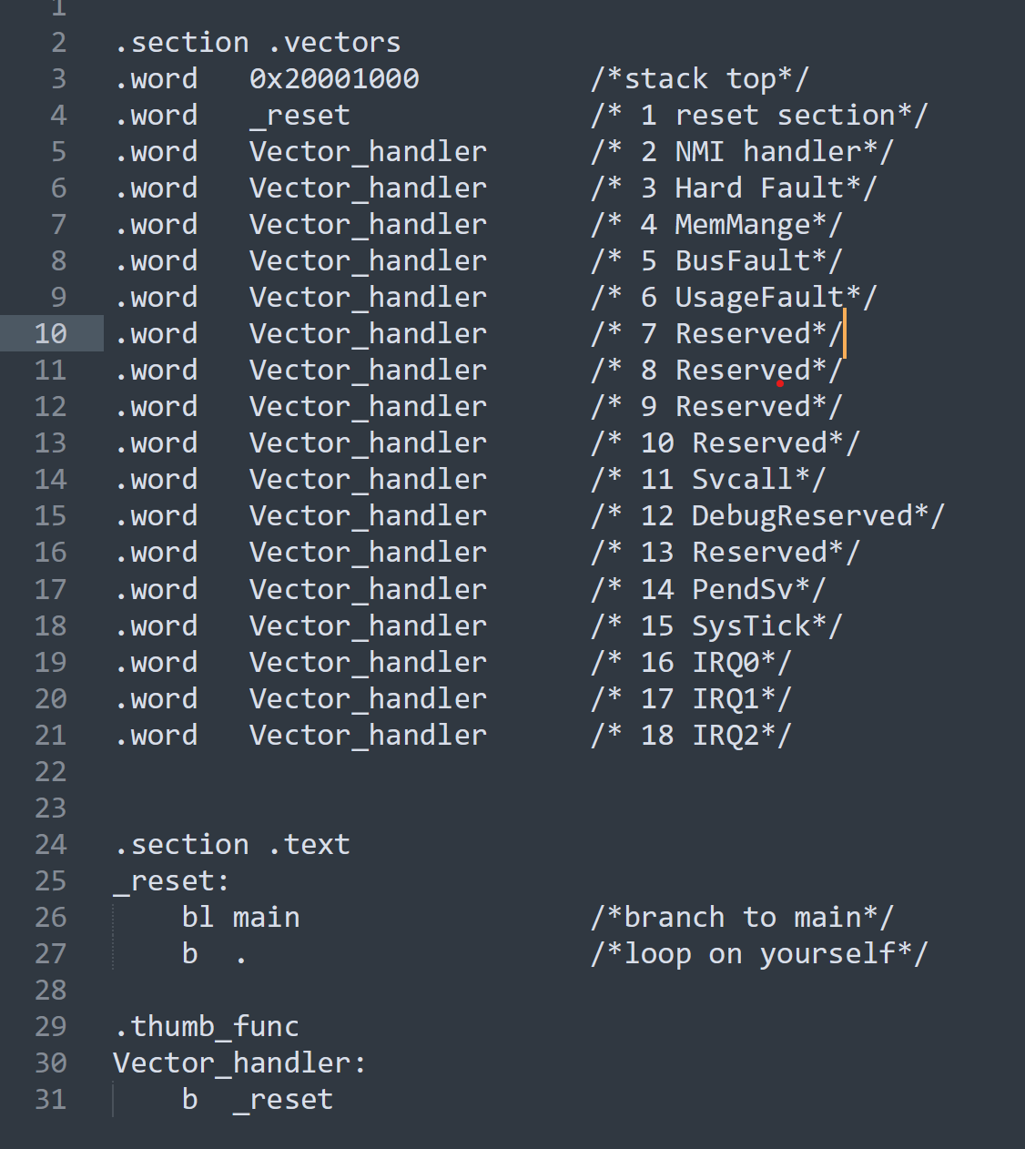

## Step 3: we will write linker_script for these files (main.c and startup.s) as shown below

## Step 4: when we all make there will be a problem that our toolchain used doesn’t support arm cortex m3 so we will use arm toolchain from stm32IDE

export PATH=/c/ST/STM32CubeIDE_1.4.0/STM32CubeIDE/plugins/com.st.stm32cube.ide.mcu.externaltools.gnu-tools-for-stm32.7-2018-q2-update.win32_1.4.0.202007081208/tools/bin:$PATH

## Step 5: run again make file

